**Separate Interface From Implementation**

|  |  |  |
| --- | --- | --- |
| *a client is directly dependent upon its server implementation* |  | *extract an interface describing the client's needs and code against that interface* |

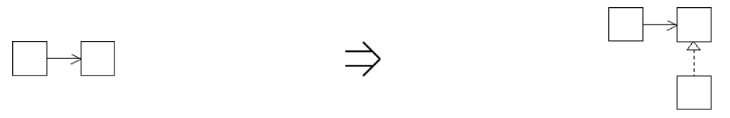

**Context:**

When client code needs to coordinate different implementations of a similar abstraction [Separate Interface From Implementation](https://web.archive.org/web/20091001201500/http:/www.refactoring.be/thumbnails/rtn-sifi.html) can be useful to [Enable Substitution With Interfaces](https://web.archive.org/web/20091001201500/http:/www.refactoring.be/thumbnails/rtn-eswi.html).

After separating an interface from its implementation it is advisable to apply [Hide Implementation With Interface](https://web.archive.org/web/20091001201500/http:/www.refactoring.be/thumbnails/rtn-hiwi.html) to any remaining clients that still acces the server implementation directly.

[Separate Interface From Implementation](https://web.archive.org/web/20091001201500/http:/www.refactoring.be/thumbnails/rtn-sifi.html) is a key refactoring to [Break Module Depencencies With Adapter](https://web.archive.org/web/20091001201500/http:/www.refactoring.be/thumbnails/ec-adapter.html)

See also :*Extract Interface[Fowler]*